C.V

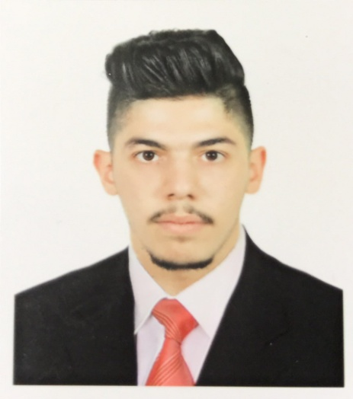

***Career Objective :***

Seeking a challenging position offering responsibility and rewarding experience

With a reputed organization and having all an environment which provides ample

Support for further development and helps me prove my worth and be an asset to

The esteemed organization.

***Personal profile :***

**Name :** Abdullah Hazim Mohammed Al-zubaidi

**Email:** [abdullahazim94@gmail.com](mailto:abdullahazim94@gmail.com)

**Mobile** : 009647707245503

**Tel**  : 0096418824127

**Date of birth :** 02/01/1995

**Gender :** male

**Place of birth:** Iraq / Baghdad/Al-adhmyah

**Nationality :** Iraqi

**Married status :** single

**Address** : Baghdad- Iraq

***Academic qualifications :*** Bsc of computer science from AL-Rafidain University College / Baghdad

I got my degree in 4 academic years .

**Year of Graduation :** 2015-2016

***Work Experience :***

* I have a good experience in computer science and programming.

*Worked as medical marketing and coordinator in India ( Fortis Hospital –Max Hospital -Artmis Hospital)

* Have significant experience of work in the field of marketing especially in Real Estates

* Worked at Happy Land Office for Real Estates/ Iraq-Baghdad .

* Good experience in application of computer programs such as IC3 ( Excel –Word-Execs) and electronic devices

* Worked at Al-selah Co. for electronic devices.

* I worked as marketing member in MaxiMall /Baghdad .

* Worked at Oranos Co. For tourist and Traveling .

* Worked at Alejaz Co. for general trading (Export &Import)

*Worked at Dar alknooz Co.

**Year of experience :** 4 years

**Training certificate** :

Computer programmer – Marketing – English language –work management - human development – Visual Basic.

.***Driving license :*** Yes

***Language :*** Arabic + English

***Personal Skills:***

* Ability to work under pressure and long hours
* Determined and open minded
* The ability to solve problem
* Proficiency in individual work and teamwork.
* The ability to build a successful social work
* Sincere, Honest & Dedicated
* Good Communication Skills

***Thank you ,Pro.Abdullah AL-zubaidi .***